**AMAN** dataset: Number of observations for genotype-group combinations

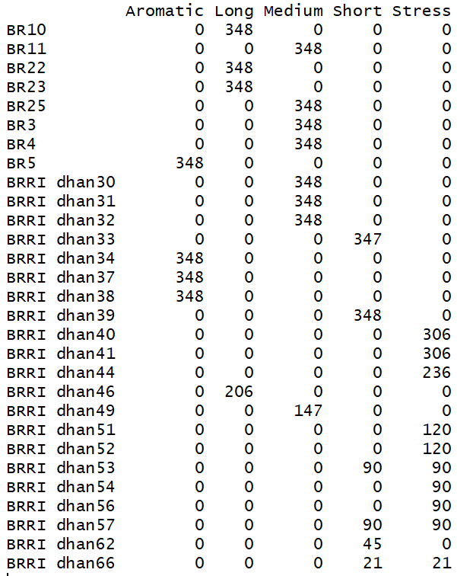

**BORO** dataset: Number of observations for genotype-group combinations

